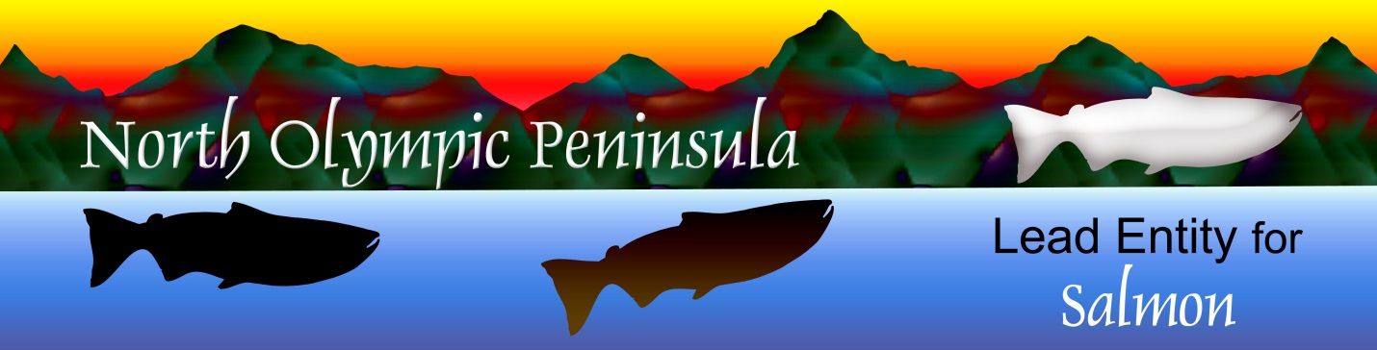
North Olympic Peninsula Lead Entity for Salmon
Clallam County Courthouse 223 E. Fourth Street, # 5 Port Angeles, WA 98362
360/417-2326

Initial Project Presentations
Wed Feb 25, 2026
9 a.m. Elwha Heritage Center,
Port Angeles, WA
Virtual Option: Listed Below

- Introductions

- Site Visits & Grant Round Updates

- 9:30 – 10:10 Dungeness Nature Center Reach Large Wood Restoration Design, Randy Johnson, Jamestown S’Klallam Tribe

Short Break while Teeing Up Second Project

10:20-11 Elwha River Restoration Design Project
Jamie Michel & Mike McHenry, Elwha Klallam Tribe

- 11-11:40 A Little River Acquisition, Jacob Stone, Forterra

- 11:50-12:30 Dungeness Riparian Forest Conservation
Randy Johnson, Jamestown S’Klallam Tribe

- Connecting & Networking

- Project Updates & Fish Reports
Join Virtual Meeting:

Topic: Initial Project Presentations
Time: Feb 25, 2026 9AM Pacific Time (US and Canada)
Join Zoom Meeting
https://us06web.zoom.us/j/89974369244?pwd=LSGKnIBvwVKx95wP6GpeAn8apUJNY6.1

Meeting ID: 899 7436 9244
Passcode: 190764

---
One tap mobile
+12532050468,,89974369244#,,,,*190764# US
+12532158782,,89974369244#,,,,*190764# US (Tacoma)

