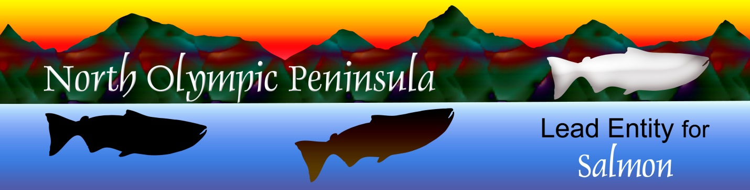

**North Olympic Peninsula Lead Entity for Salmon**

Clallam County Courthouse 223 E. Fourth Street, # 5 Port Angeles, WA 98362

360/417-2326

|  |
| --- |
|  |

Tues. Mar. 4th, 2025 Site Visits

8: 45 a.m. Gather at Clallam County Courthouse Back Parking Lot Up by Building

Carpools Arranged

9 a.m. – Carpool Departs Courthouse driving to Clallam Bay County Park,

16716 Frontier Street, Clallam Bay WA

10:15 – 10:45 Restroom Break & am Snacks at Clallam Bay County Park

10:45 -11 Drive to Hoko Reveg Site

11– 11:45 Hoko River Watershed Riparian Restoration,Nate Roberts, NOSC

<https://secure.rco.wa.gov/PRISM/Search/ProjectSnapshot.aspx?ProjectNumber=25-1077>

11:45-12:45 Drive to Elwha Ranney Reach Overlook- NOT the site we normally go to!

West side of river by Sisson Road

[https://maps.app.goo.gl/iJY5a8Zwyg9uQXiw8](https://gcc02.safelinks.protection.outlook.com/?url=https%3A%2F%2Fmaps.app.goo.gl%2FiJY5a8Zwyg9uQXiw8&data=05%7C02%7Ccheryl.baumann%40clallamcountywa.gov%7C074dd72dc1c647937e2408dd578837fc%7Cc065de0bacb04822b9683e84b9d37980%7C0%7C0%7C638762964750453715%7CUnknown%7CTWFpbGZsb3d8eyJFbXB0eU1hcGkiOnRydWUsIlYiOiIwLjAuMDAwMCIsIlAiOiJXaW4zMiIsIkFOIjoiTWFpbCIsIldUIjoyfQ%3D%3D%7C0%7C%7C%7C&sdata=2fHSz%2BnwTrMjWcnRejRaoCaSCxtbWa3AbC4DdtR8VHE%3D&reserved=0)

12:45-1:30 Ranney Project Site Update- Jamie Michel, Elwha KlallamTribe

1:30-1:45 Drive to Elwha Riparian Revegetation & NW Control

<https://maps.app.goo.gl/8wDuyXNx7yuHSunu8>

12:45-1:30 Elwha Riparian Reveg & NW Control -Allyce Miller, Elwha Klallam Tribe <https://secure.rco.wa.gov/PRISM/Search/ProjectSnapshot.aspx?ProjectNumber=25-1079>

1:30-1:45 Drive to McDonald Gauge Reach Restoration

McDonald Gauge Reach Site:

<https://maps.app.goo.gl/9v7dMDJwwnEm31Bu6>

1:45-2:30 Elwha Floodplain Restoration Design-McDonald Gauge Reach

Jamie Michel, Elwha Klallam Tribe

<https://secure.rco.wa.gov/PRISM/Search/ProjectSnapshot.aspx?ProjectNumber=25-1004>

3:00-4 approx. Arrive back at Clallam County Courthouse

Key: Green Highlighting is Drive Times

Light Blue highlighting is maps & addresses

Pink highlighting is warning

Royal blue is Project info in Prism Snapshot for Proposed Projects

Lost or need info?:

Cheryl Baumann, 360/912-4152