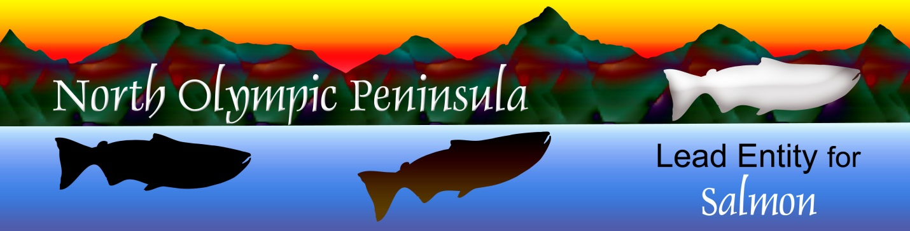

**North Olympic Peninsula Lead Entity for Salmon**

Clallam County Courthouse 223 E. Fourth Street, # 5 Port Angeles, WA 98362

360/417-2326

Nov. 20, 2024

Lead Entity Group Meeting

Elwha Heritage Center

9:30 – 12 Noon

Agenda

1. Introductions
2. 2025 Potential Calander
3. Coordinator Updates
4. Meeting Summary Approval
5. Anything Else for the Good of the Order?

Topic: LEG Meeting

Time: Nov 20, 2024 09:30 AM Pacific Time (US and Canada)

Join Zoom Meeting

<https://us02web.zoom.us/j/88324870931?pwd=jssV8AO3DKzve9VQA3iBM2WPi7NCt3.1>

Meeting ID: 883 2487 0931

Passcode: 223017

---

One tap mobile

+12532158782,,88324870931#,,,,*223017# US (Tacoma)

+12532050468,,88324870931#,,,,*223017# US